

National Textile University

**Department of Computer Science**

Subject:

Operating System

Submitted to:

Sir Nasir

Submitted by:

Asbah Asif

Reg number:

23-NTU-CS-1141

Lab no: 03

Semester: 5th

**Task 1:**

**Code:**#include <stdio.h>

#include <unistd.h>

int main() {

pid_t pid = fork();

if (pid == 0) {

// This block runs in the child process

printf("Child: PID=%d, Parent=%d\n", getpid(), getppid());

} else {

// This block runs in the parent process

printf("Parent: PID=%d, Child=%d\n", getpid(), pid);

return 0;

}

**Output:**

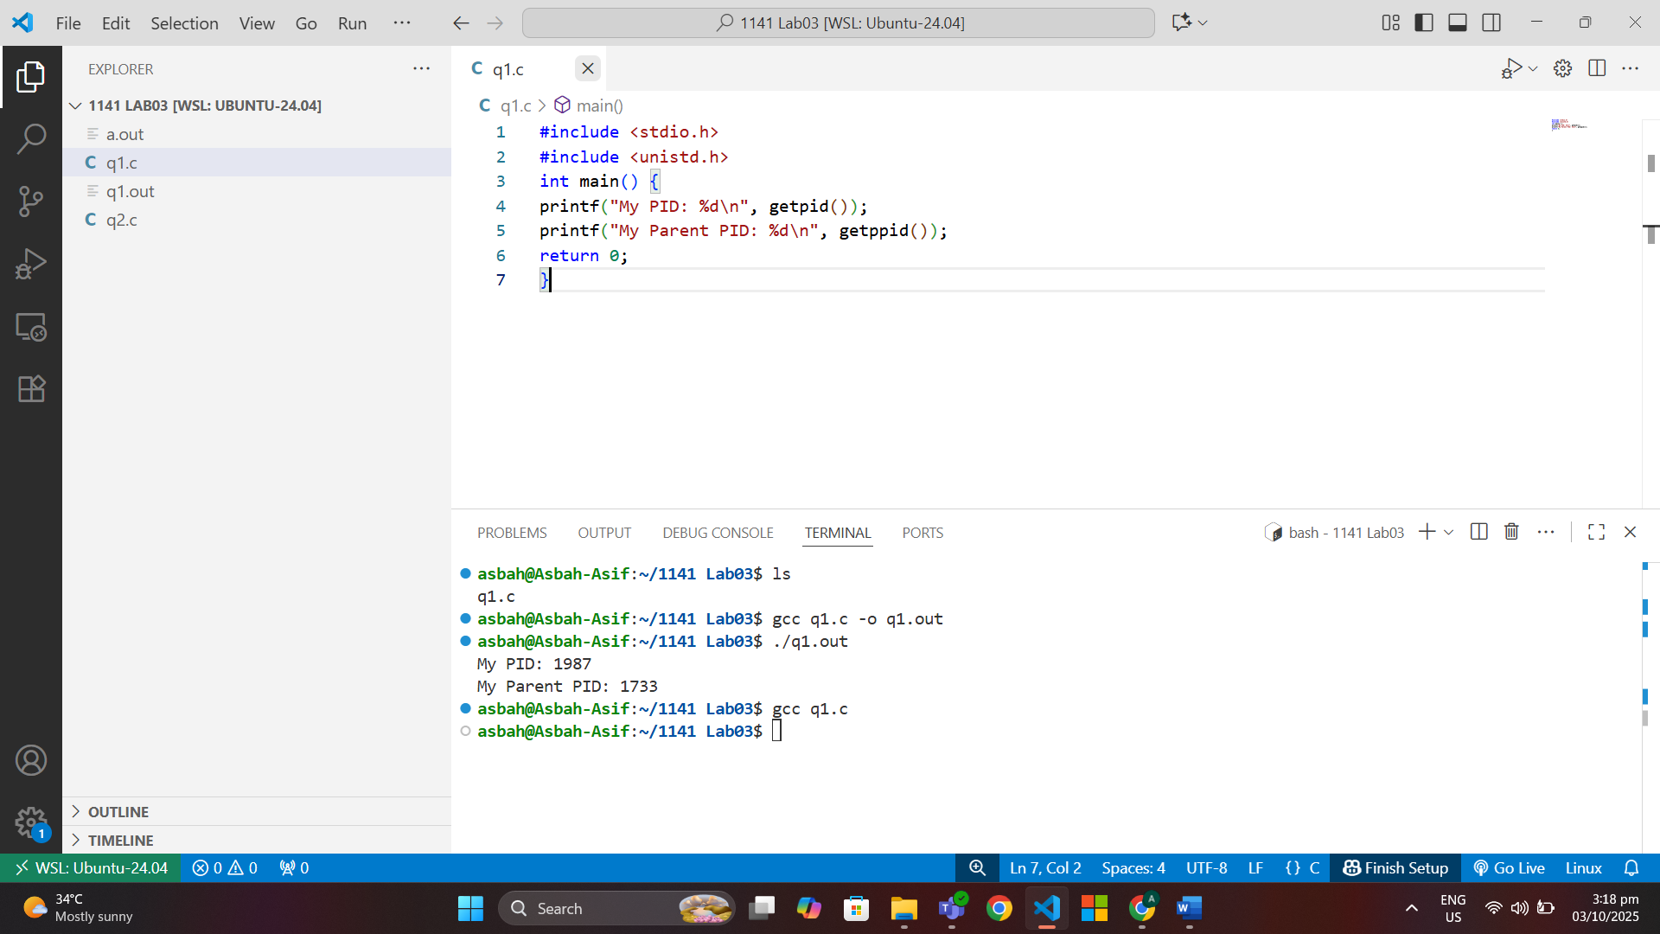

**Task 2:  
Code:**#include <stdio.h>

#include <unistd.h>

int main() {

pid_t pid = fork();

if (pid == 0) {

// This block runs in the child process

printf("Child: PID=%d, Parent=%d\n", getpid(), getppid());

} else {

// This block runs in the parent process

printf("Parent: PID=%d, Child=%d\n", getpid(), pid);

}

return 0;

}

**Output:**  
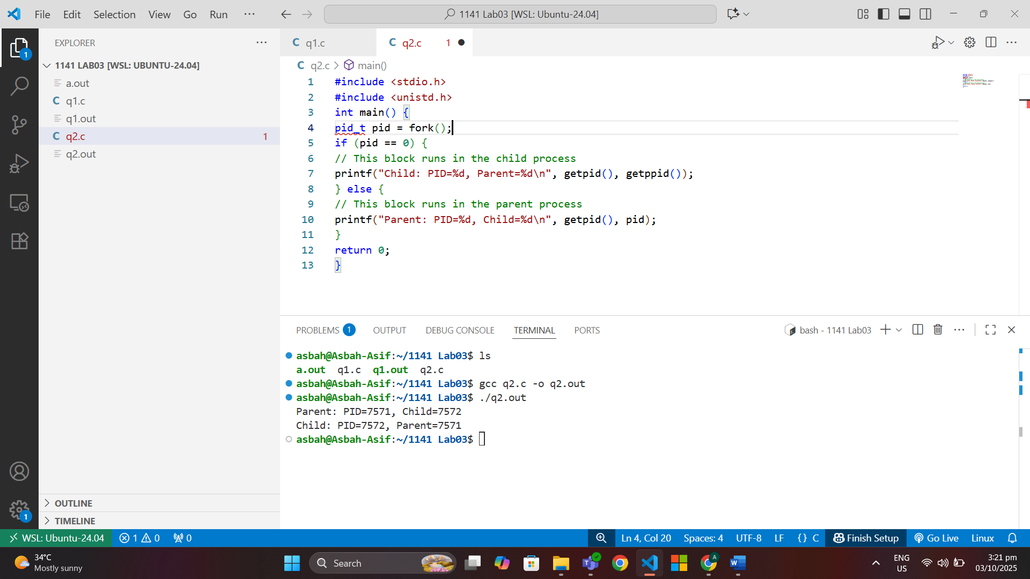

**Task 3:**

**Code:**

#include <stdio.h>

#include <unistd.h>

int main() {

pid_t pid = fork();

if (pid == 0) {

execlp("ls", "ls", "-l", NULL);

printf("This will not print if exec succeeds.\n");

} else {

printf("Parent still running...\n");

}

return 0;

}

**Output:**

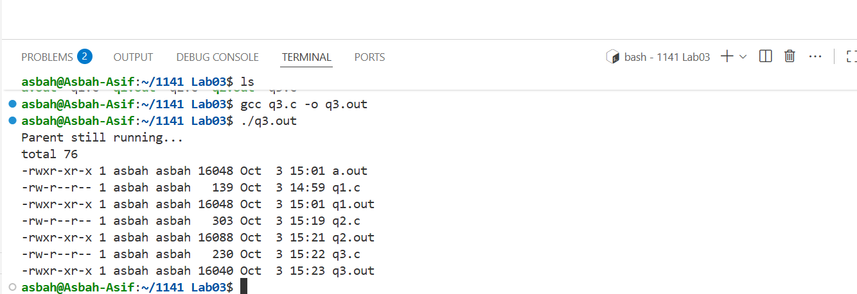

**Task 4:  
Code:**#include <stdio.h>

#include <unistd.h>

#include <sys/wait.h>

int main() {

pid_t pid = fork();

if (pid == 0) {

execlp("ls", "ls", "-l", NULL);

printf("This will not print if exec succeeds.\n");

} else {

waitpid(pid, NULL, 0); // Wait for the child process to finish

printf("Parent still running...\n");

}

return 0;

}

**Output:**

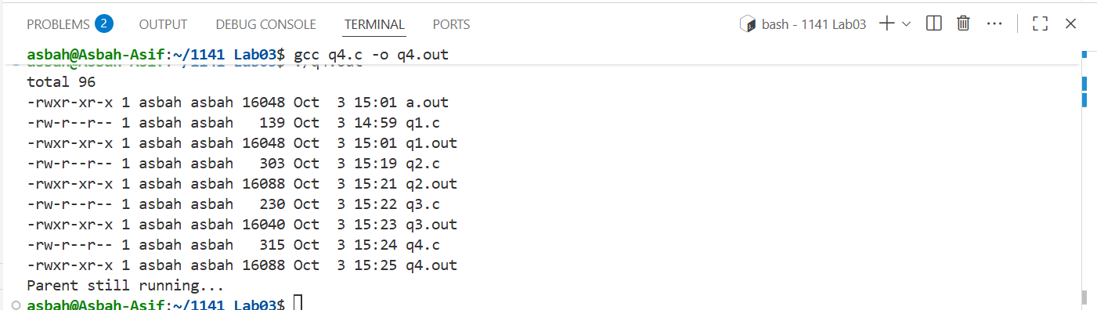

**2.1:**

**🡪Ps-ef**

**🡪ps -ef | grep bash**

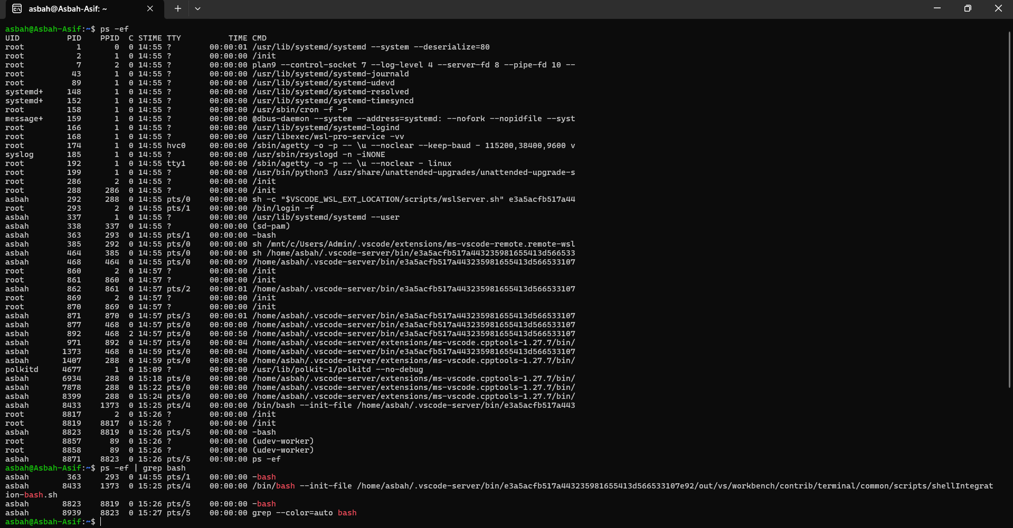



**🡪TOP**

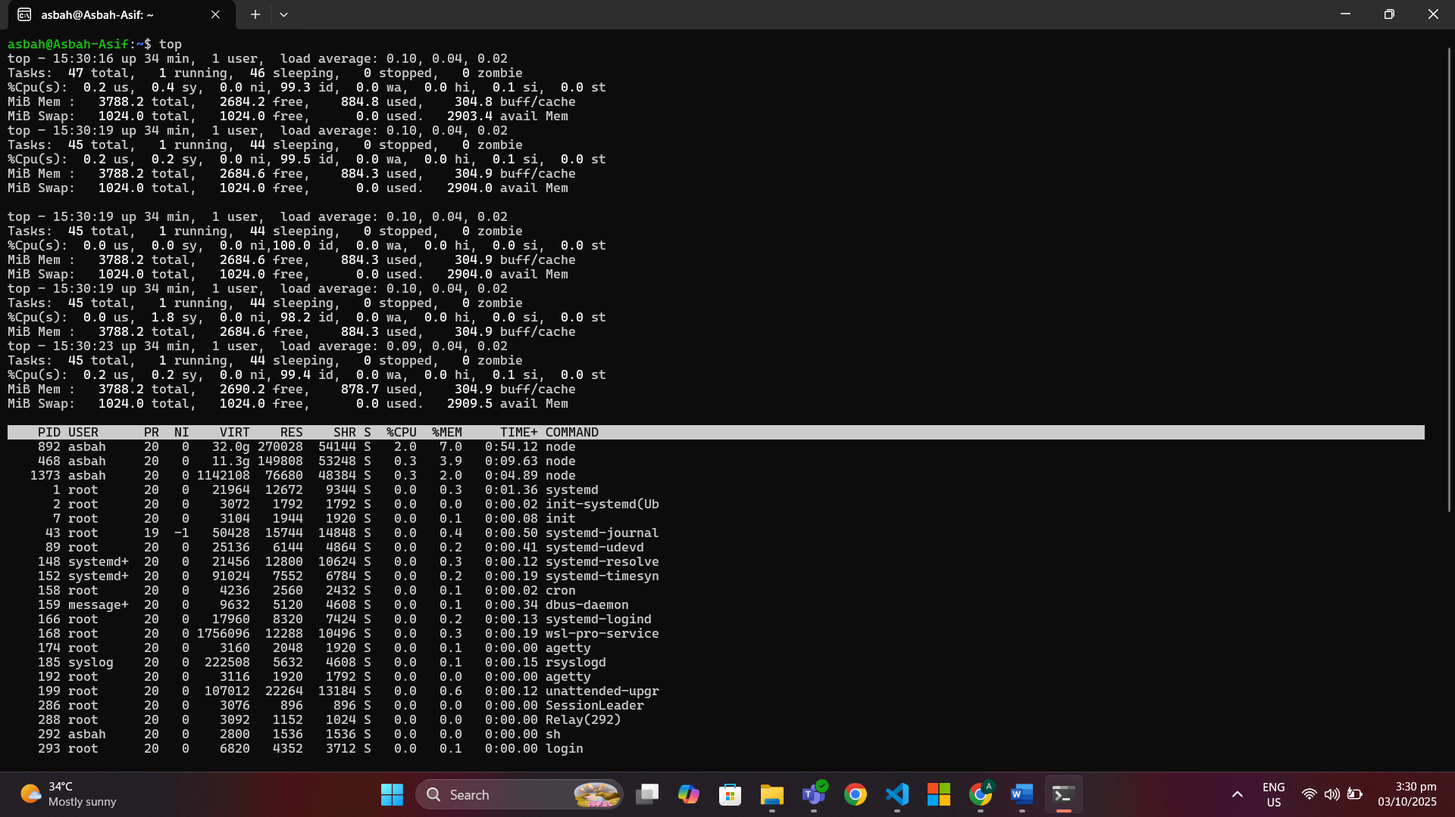

**🡪Sleep**

**🡪Sleep 10 &**

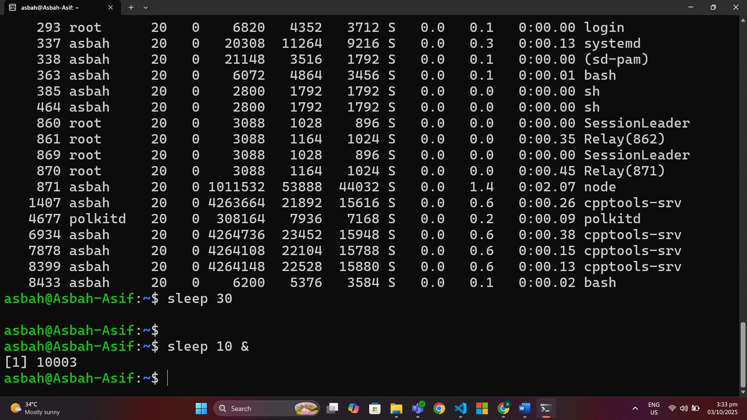

**🡪Jobs**

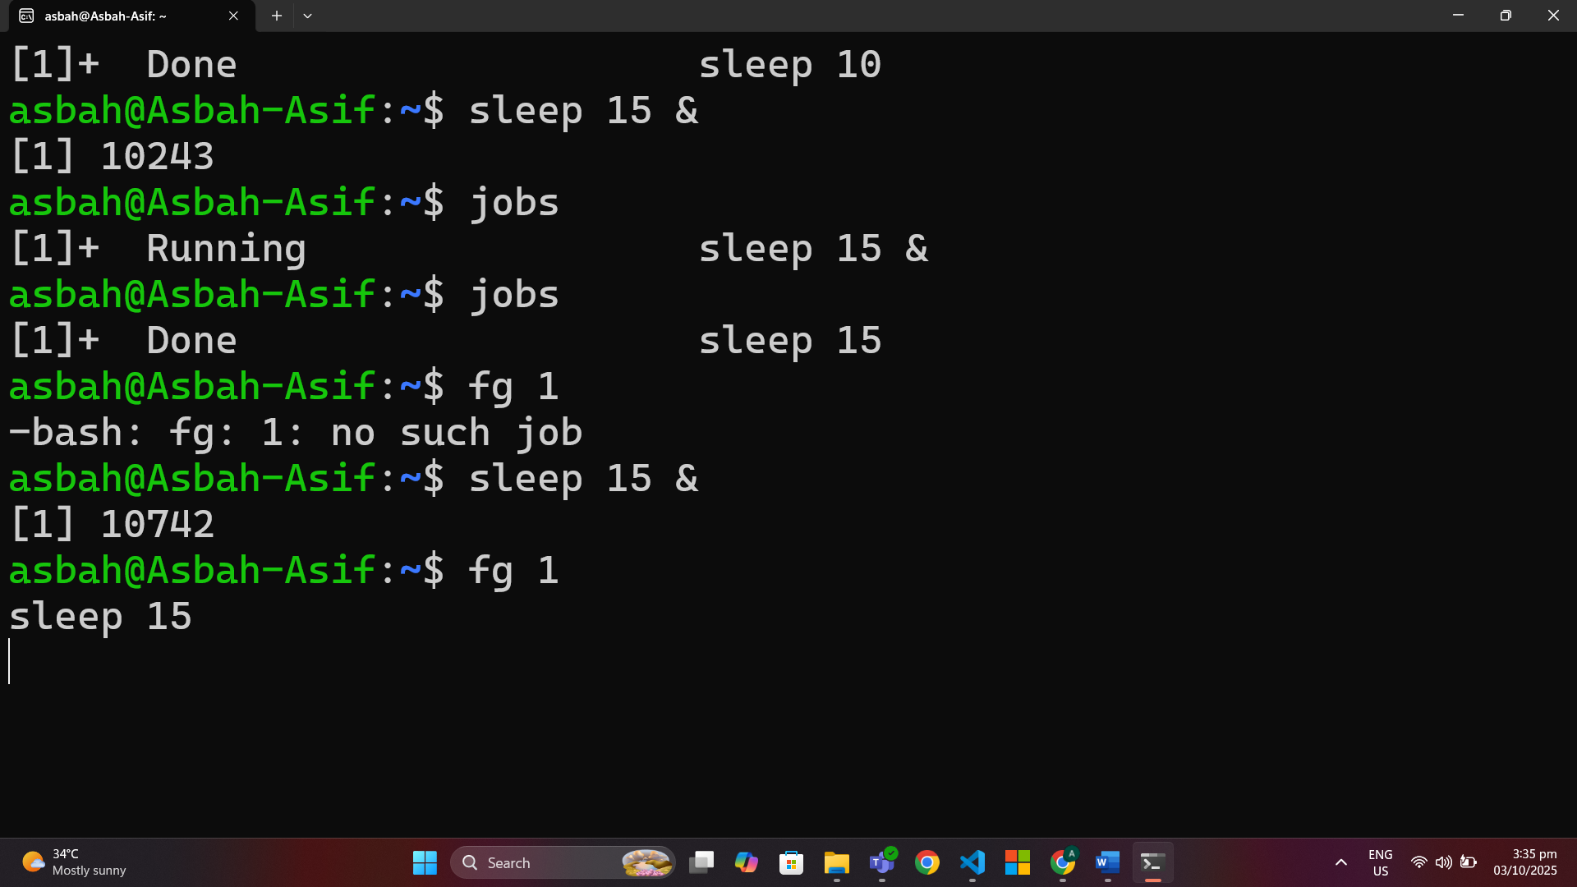

**a🡪pidof**

**🡪Kill**

